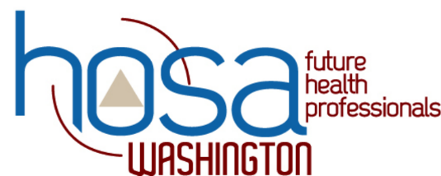
STATE LEADERSHIP CONFERENCE 2018
Request your preferred Event to assist with

In order to ensure each event runs smoothly, with integrity and organization, and in our best efforts to provide a positive experience to each HOSA delegate, we need an advisor from EACH chapter to take on a competitive event as an Event Manager, timekeeper, recorder, pronouncer, etc. WA-HOSA will be relying on the skills and talents of our HOSA Advisors to help properly execute events at the State Conference. In order to match you with your preferred area, please complete the form below. Please also sign up any chaperone/guest/administrator/student from your chapter that is willing to help as well. If you know your HOSA Chapter is willing to cover all personnel needed for a specific event, please indicate that as well and we will contact you about the total personnel needed. Without your indicated preference from this form, you will be assigned to a remaining event that is in need of assistance.

As you are deciding on you event preference, please consider the following:

*If you are an ADVISOR, you can only assist with events your chapter does NOT have any student registered.
*What events were your students interested, but unsure about. This is a great opportunity to see this event first hand.
*Those of you without students attending, again, this is a great opportunity to get a better understanding of what HOSA's SLC is all about.
*What event will YOU enjoy helping with the most?

As advisors, we strive to provide a positive, leadership model for our students and this is a fantastic opportunity for students to witness us as adults investing in each other to create a better experience for all. I know together, we all can make this great, and this is an excellent opportunity to see first-hand what goes on in a competitive event, enabling you to better explain to students and parents what the State Leadership Conference is all about. You will have help! The planning committee will help answer questions and be available if issues arise. This is a successful model that has worked for many other states for numerous years. As HOSA enters its 41st year, and WA HOSA its 5th, we know our conferences will continue to grow yearly and it will be impossible to conduct a successful conference without the help of EVERY advisor.

You will notice this year’s form is out a little earlier, and asks for additional information. In an effort to increase communication and better assist everyone in their assigned role, we will be contacting everyone to review what is needed and answer any questions you may have.
Thank you in advance!

Advisor Event Preference Form

To view descriptions of events please visit pages 3-5 of Summary of Events.

